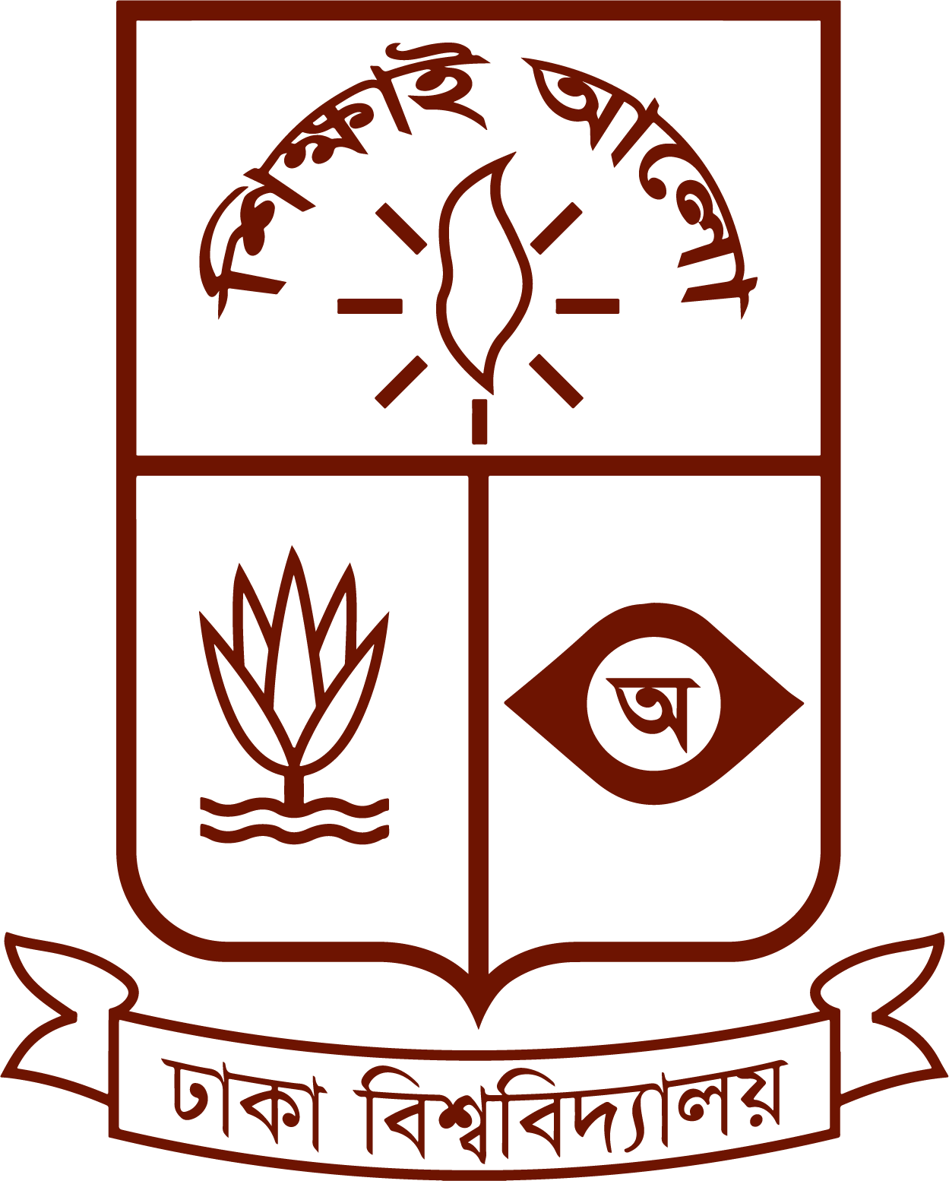 | MANICC 2026  “Advances in Surface Chemistry & Colloidal Science”  Organized by the Department of Chemistry  University of Dhaka | 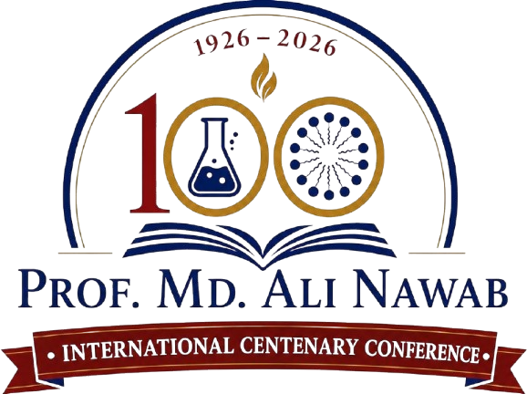
Prof. Md. Ali Nawab International Centenary Conference

Title of Abstract Should Be Concise, Informative, and Capitalized in Title Case (Calibri, 13pt Bold)
First Author Name^{1,*,} Second Author Name^{1,2,} and Corresponding Author Name²
1 Department of Chemistry, University of Dhaka, Dhaka-1000, Bangladesh
2 Research Center / Institution Name, University / Organization, City, Country
* Corresponding Author Email: author@domain.ac.bd
Abstract: Please provide a concise and structured abstract of no more than 250–300 words. The abstract should clearly state the background, objective, methodology, key findings, and scientific significance of your research. It should be written in a single-paragraph format using 10pt Calibri font. The conference themes center on physical chemistry, colloidal science, surface phenomena, nanomaterials, catalysis, soft matter physics, adsorption science, and environmental applications. Ensure that all technical terms and chemical formulas are clearly formatted. Avoid citations or references in the abstract text.
Keywords: Colloidal Science; Surface Chemistry; Nanomaterials; Adsorption Science; Catalytic Mechanisms (3–5 keywords)

PRESENTATION TYPE & THEMATIC TRACK SELECTION
Presentation Type: | ☐ Poster Presentation (Open to All) ☐ Oral Presentation (By Invitation Only)
Conference Track: | ☐ Surface & Colloidal Science ☐ Nanomaterials & Catalysis ☐ Soft Matter & Environment
Presenting Author: | Full Name: _______________________ Email: _______________________
Award Eligibility: | ☐ Eligible for Best Poster Award ☐ Student / Early-Career Scientist

Submission Guidelines & Key Deadlines:
• Abstract Deadline: 05 October 2026 | Provisional Acceptance: 20 October 2026
• Submission Email: abstract-manicc2026@du.ac.bd (strictly MS Word .docx format, 1-page limit)
• Official Website: https://manicc2026.du.ac.bd/ | Venue: Nawab Ali Chowdhury Senate Bhaban, DU

